**Professional Behavior Template Example**

1. **Interacting Professionally with the Instructor:**I’ve spoken to you only twice through email, and briefly, but I did my best to be respectful and formal in my writing. I inquired about an issue I had with a link you provided in the announcements and expressed my concerns about hibernate. You responded by creating a hibernate tutorial, which I’ve been very thankful for, though I’ve yet to look at it, as I’ve scheduled hibernate further down in the semester for myself: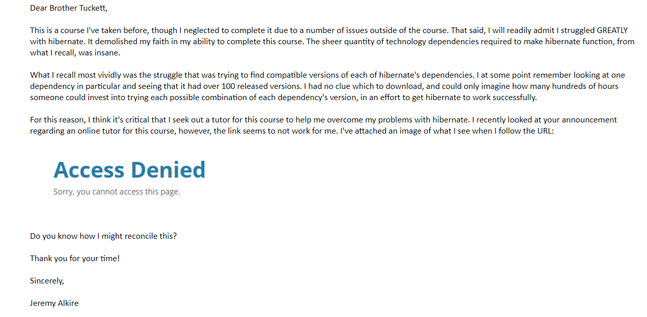
2. **Interacting Helpfully and Professionally with Other Teams:**Today was the first day that I really participated in the developer forum. I regret not having done so previously but tried to make up for it today. I hope to remain active on the developer forum in the future as well. I wrote a lengthy explanation of two constructors that were deprecated in version 9 of Java, and then outlined what alternative approaches people could take, in lieu of their deprecations:  
     
   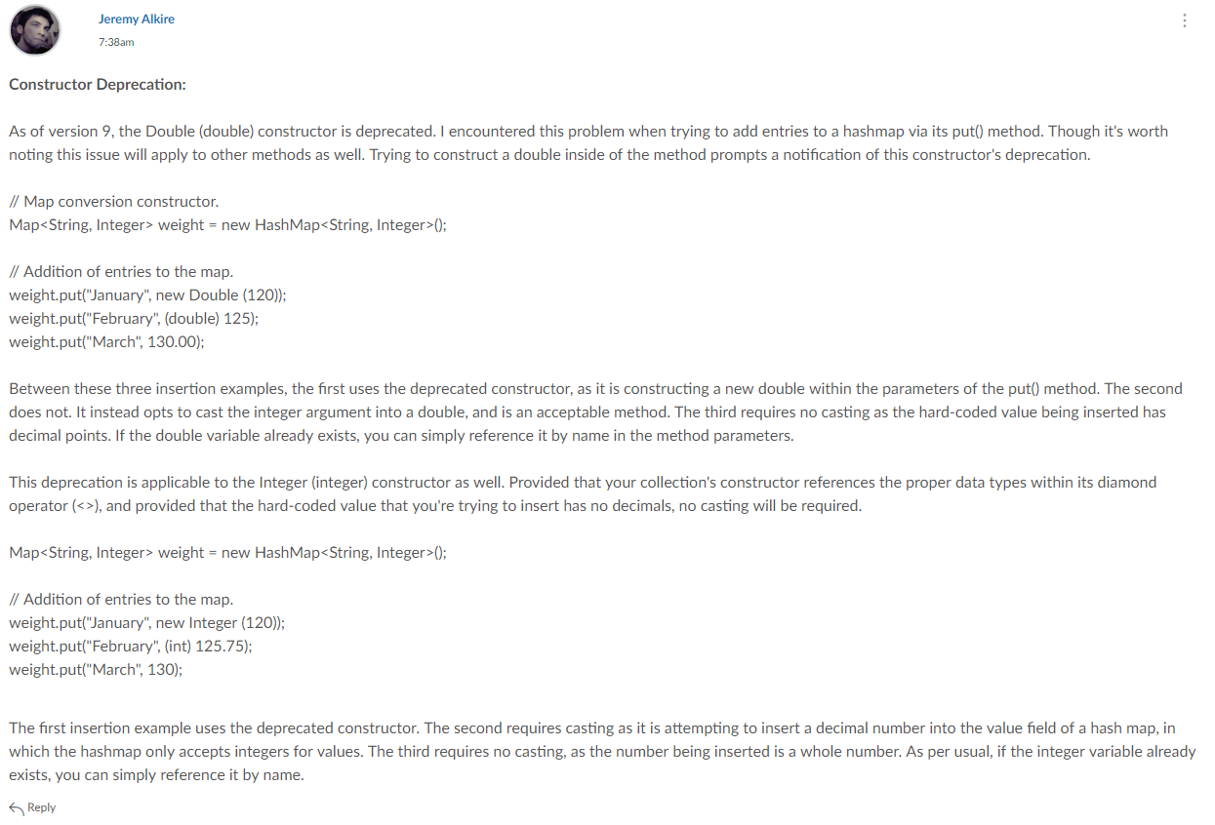
3. **Supporting the Team by Teaching, etc.**I didn’t get into contact with my group for the first few weeks of the semester. Last week was when I finally got in touch with them. This week I created and sent a video tutorial to them in which I taught about Java Collections. I walked through a large, detailed power point teaching the intricate concepts of Java Collections and   
   followed up by walking through some coding examples that I wrote myself. I’ve been keeping in touch with them via our Google Hangouts group:  
     
   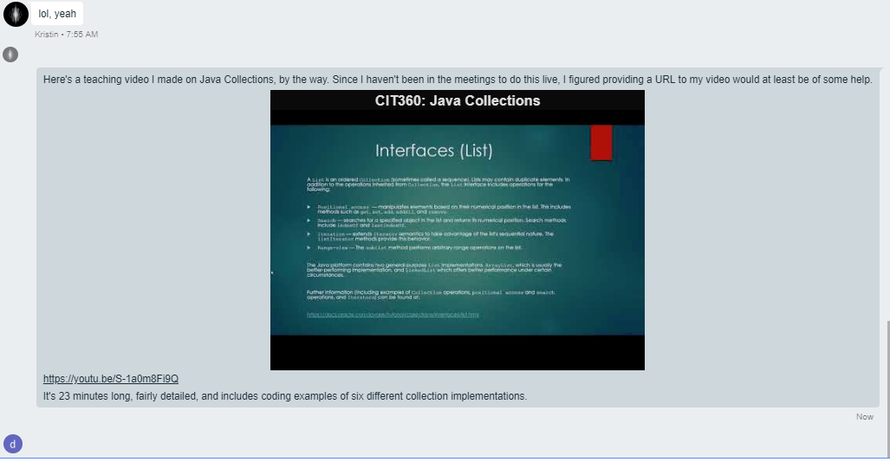  
     
   The full video is here: <https://youtu.be/S-1a0m8Fi9Q>
4. **Self-Reflection/Meta-Cognition:**I’ve had to self-reflect a lot this semester already. Primarily regarding my own time management. I often wait until very late into the week to open and look at my course work, which is a part of why I miss due dates. I’ve learned that if I want to keep up, I’ll have to at minimum look at my assignments by Monday, ideally begin them by the same, and at minimum begin them by Wednesday.  
     
   It will additionally be helpful if I set aside anything that can potentially distract me, such as my cell phone, social media, and so forth. For the first few weeks of the semester I had an almost entirely nocturnal sleeping schedule and have recently reconciled that completely. It should greatly help me to manage my time better and stay on top of my responsibilities.
5. **Team's Agile Methodology:**Our team chose the scrum methodology. Though we don’t meet via video daily, we do chat daily in our hangouts group.
6. **Professional Scheduling Group:**To my knowledge we don’t have a specific schedule regarding teaching topics. As it was told to me, when we meet, whoever teaches is dependent upon who knows a certain subject, and what they feel comfortable with teaching at that time. We try to meet by Wednesday each week.